Deploying MYSQL with AWS:

Connecting to AWS MYSQL RDS Instance:

Creating a new user:

Users_db on AWS reflecting the changes:

Two Factor Authentication Library. Secret Key will be updated before deployment. Using the current time but rounded down to the nearest 3 minutes. 2FA Codes will be unique every 3 minutes

Method that generates a unique six digit code that is valid for 3 minutes based on the username, the rounded time and a secret key:

Method that generates a hash from the username and the tfa code for comparison, if no tfa code is provided the current tfa code will be used:

Method that validates a login for a user based on their username and tfa_code

Creating a basic login form for the API, testing the API by simply sending back the login info:

Form is correctly hitting the API endpoint:

Login Process:

After many failed attempts first successful login:

User_logins table functioning:

Login attempt with incorrect password:

Failed attempt saved in db:

Lockout Feature explanation and screenshots. When a user fails a login the failed_login_count column in the database increments (starts at 0). If the user fails 3 logins the following happens:

1. locked_out column is set to 1 (default is 0)
2. locked_out_end is set to 5 minutes from now
3. failed_login_count resets to 0
4. All logins from the user will be blocked until the locked_out_end with a 403 code until time has passed

Database with an active lockout:

Successful login with redirect to 2FA page:

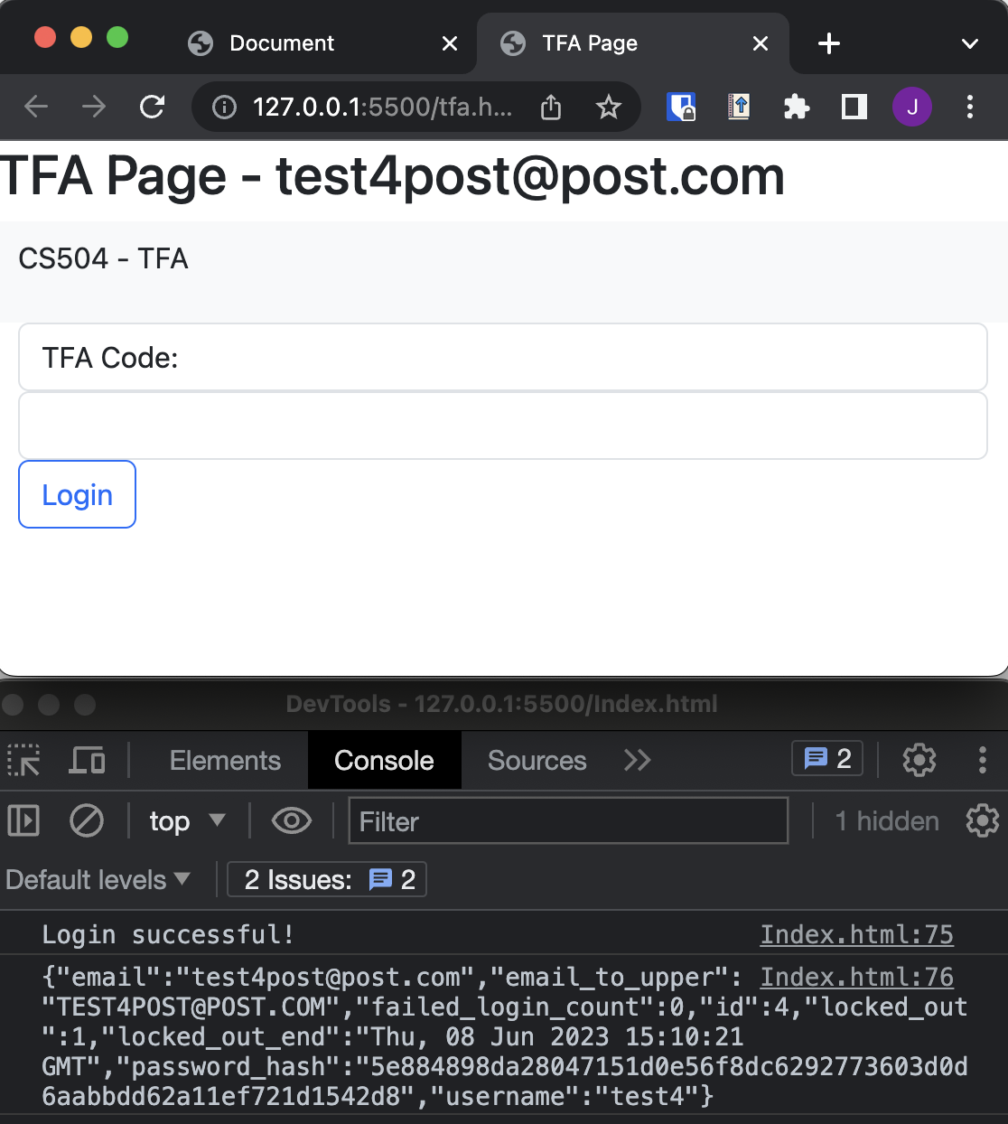

TFA_Code generation with postman:

Code updates automatically with the time:

Testing for Validation:

Code has expired:

It finally works!

Adding SMS Service:

Unfortunately SMS is not working due to restrictions on the number that we are sending from:

For example this works and triggers on login:



However as soon as we try to concatenate the 2FA code it fails.

The process to register our phone number would take 2-3 weeks. As of right now we do not have a way to send the user the 2FA Code.

For this reason I am including the 2FA code on another html page. We could easily implement SMS but we would need to go through this verification process first.

Here is the current complete login process using a test user on the live AWS database:

